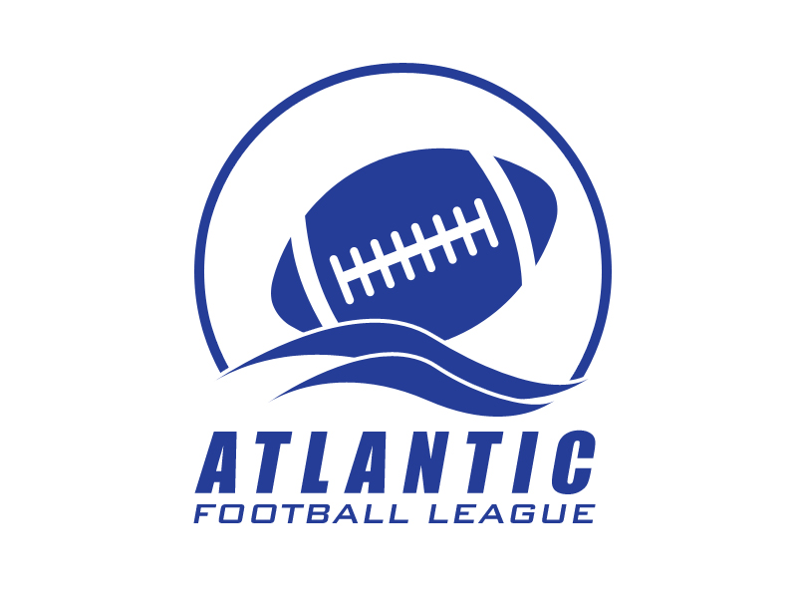

2013 Annual General Meeting
Minutes
May 10, 2014 – 10:00 a.m.
Moncton Football Association Building, Centennial Park, Moncton, NB

Participants:

Executive: Terry Allen, Commissioner, Larry Timms – Secretary/Treasurer

Board Members: Fredericton Red Bombers – Larry Wisniewski. Mike McSorley
Saint John Seawolves – Barry Ogden
Holland College Hurricanes – Mike O’Grady, Vernon Doyle
Dalhousie Tigers – Rick Rivers, Jim Wilson

Others: Andrew Bubar, FBFOA, Al Wetmore, Coach, Dalhousie Tigers

- Agenda - Prior to adopting the agenda, 2 amendments were made to it - adding under item 7, Reports – Officials and, under 14. Other Business, All-star Recognition and Player of the Game.

- Minutes of the 2012 AGM. Larry tabled the minutes of last year’s AGM. Jim Wilson made a motion to adopt these, seconded by Barry Ogden and they were unanimously accepted.

- Business arising from the minutes / action items

  - It was noted that the Action items Website, Vice-Commissioner, Media Coverage and All-star recognition were all items to be covered in the current agenda.
  - Vernon noted he had followed up on the sponsorship issue with some of his contacts without any success.
  - The one change to the Bylaws (team colours) is now included in the AFL Bylaws

- Correspondence – There was not correspondence tabled.

- Reports –

  - Commissioner – Terry gave a verbal report on the 2013 season, summarizing it as a very successful year without any major issues. He noted that all games were very competitive. Terry indicated he had had some correspondence from the Canadian Junior League which had been distributed to the Board, at this time no action is planned..

  - Treasurer – Larry tabled the 2013 Financial Statements noting that there were some variances in individual line items but the bottom line was close to what had been anticipated.

  - Teams – Each team gave a brief verbal report of their year’s results. Jim Wilson did raise an issue that they were seeing sizeable busing cost increases, but other teams had not encountered that.

  - Officials – Andrew Bubar of the NBFOA provided a very good summary of the changes in the rules for the coming season and responded to queries from the floor. He also raised the issue of ‘Split Officials’ for the playoff games, noting, although it was a good process, it could add cost due to additional travel. He noted a further change in 2015 would impact sweater number eligibility. Andrew indicated these rule change, once finalized would be distributed to all leagues.

- 2014 Budget – Larry tabled a draft copy of the proposed 2014 Budget. After some discussion, it was felt we should wait until the question of a new website / administrator is resolved and the financial impact that might have before we finalize the budget and the resulting team fees for the 2014 season. This was unanimously agreed to.

- Constitution/Bylaws – There we no changes proposed

- Election Of Officers – Both Terry and Larry offered to remain on in their position and with no new names presented, it was unanimously agreed that their terms would be extended for 1 year.. It was re-iterated that we continue to work on getting a Vice-commissioner. Rick Rivers and Jim Wilson will look into the possibility of attracting someone from NS who might be interested in this position. Once this new position was in place, a succession plan could be established. For continuity, it was recommended that election of new officers would alternate years.

- Website – There was general consensus that more had to be done with the AFL website and that a part time administrator be found to maintain it. Discussion also took place as to whether Point-Streak was the best platform (another option being Goal Line). Jim Wilson agreed to investigate this issue and get back to Board ASAP with a proposal. This could impact the annual team fees.

- Post season game with a team from another league (CEGEP, etc.) – It is believed that the idea of having a post-season exhibition game could increase the profile for the AFL. It was agreed that we should contact other leagues to investigate any options. Terry and Mike will lead this initiative..

- 2014 League Schedule – Terry had circulated couple of draft schedules. It was generally accepted and each team was to confirm start times and get back to Terry ASAP so it can be finalized and distributed to the media.

- Other Business –

- All-star selection – It was noted that the plan agreed to last year did not occur in a smooth process. The recommendation from last year was:
1) Provide framed certificates for each all-star,
2) ensure there is a press release once the selections had been finalized,
3) Ensure the names of all all-stars are posted on the AFL website.
The plan is to ensure selections are made a week after the season ends and certificates distributed as soon thereafter as possible.

- Tie breakers – Although a procedure is in place for tie breakers ion the playoff, there is nothing currently set out for regular season games. It is proposed that we implement the CIS model, with a compulsory attempt for a 2 point conversion on the second series if still tied after the first series. Moved by Barry, seconded by Mike. Approved.
- Player of the Game – It was agreed to continue with each team selecting a player of the game for every game and ensuring this is posted to the AFL website.

- Timing for next meeting – it was felt that the second or third Saturday in May would work well for next year’s AGM timing. Delaying it by an additional week might allow field dates to be finalized.

- Adjournment – Moved by Mike seconded by Rick to adjourn the meeting at 12:30 pm

Action Items Responsibility

Website - Administrator Jim Wilson

Vice-Commissioner Rick Rivers / Jim Wilson

League Media Coverage All

Schedule Finalization All / Terry

Post Season Game with another league Mike / Terry

2013/ 2014 All-star recognition Terry/Larry

New Rules for 2014 distribution Andrew Bubar / Terry Allen

Split Officials – Playoff Games To Be discussed further

